CLOUD COMPUTING
Lab 02

Name: Abiha Nadeem

Roll no: 2023-BSE-001

Submitted to: Engr. Muhammad Shoaib

- Install Git on your PC

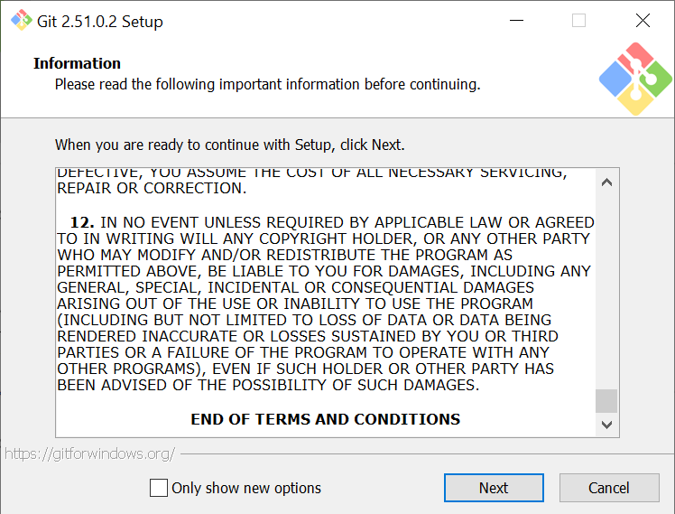

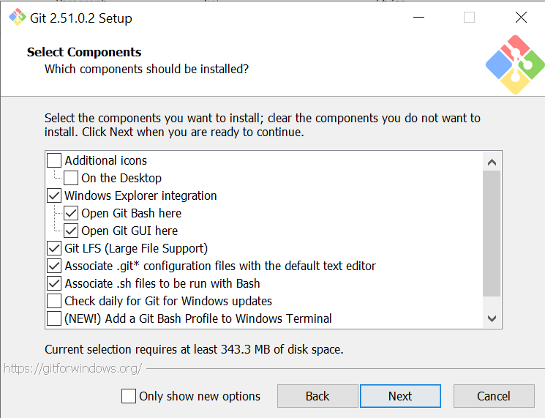

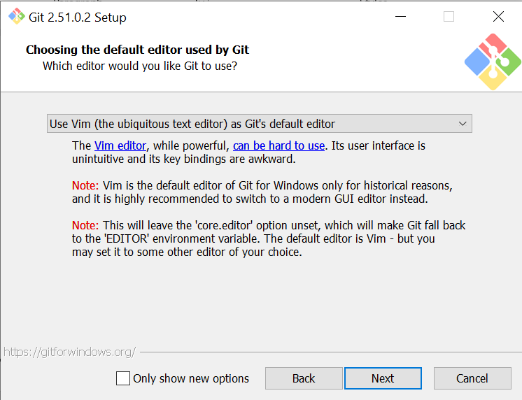

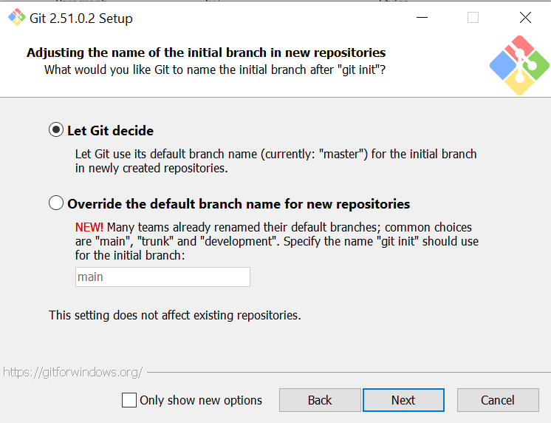

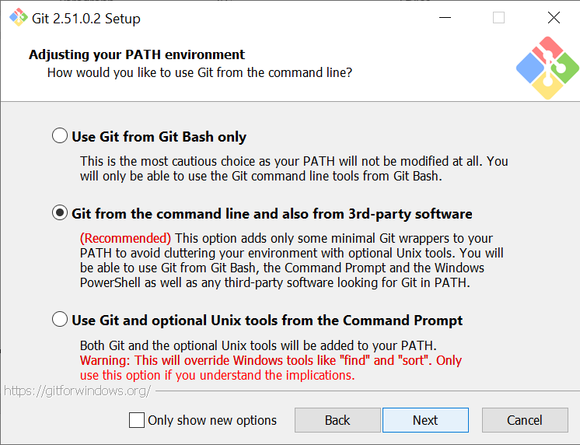

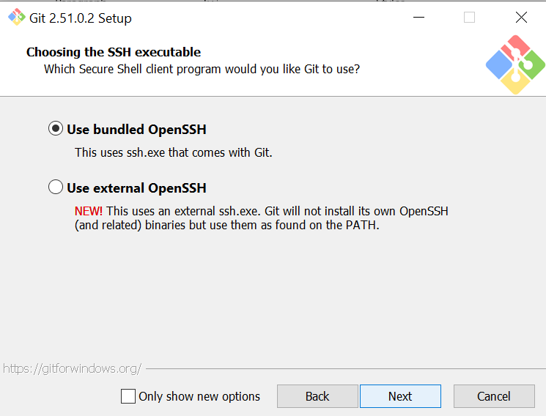

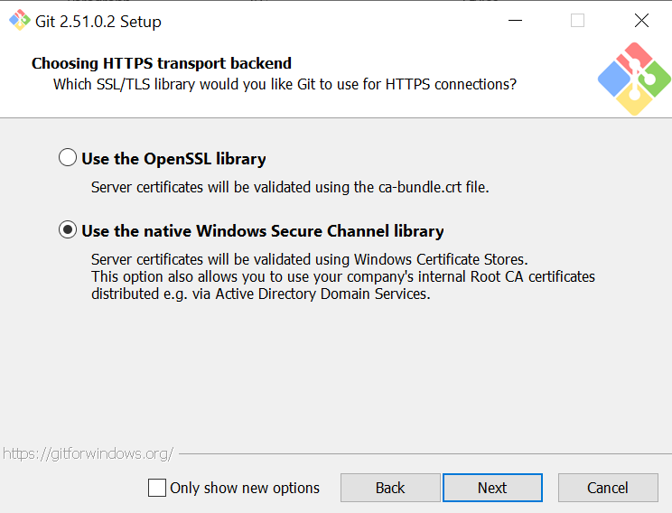

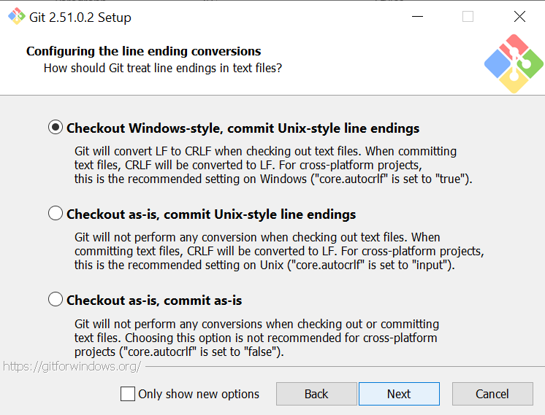

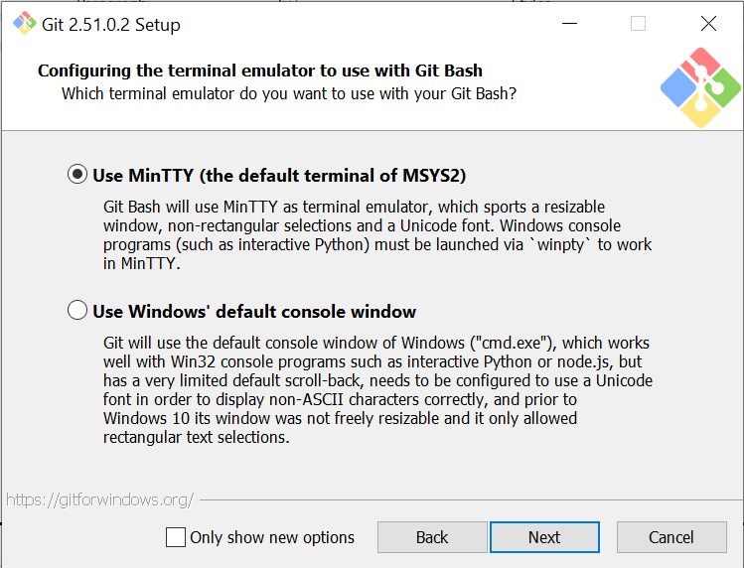

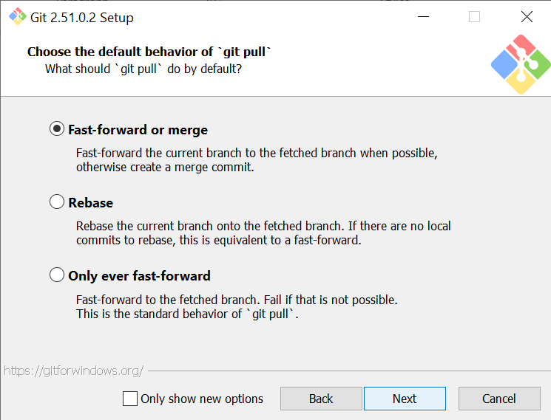

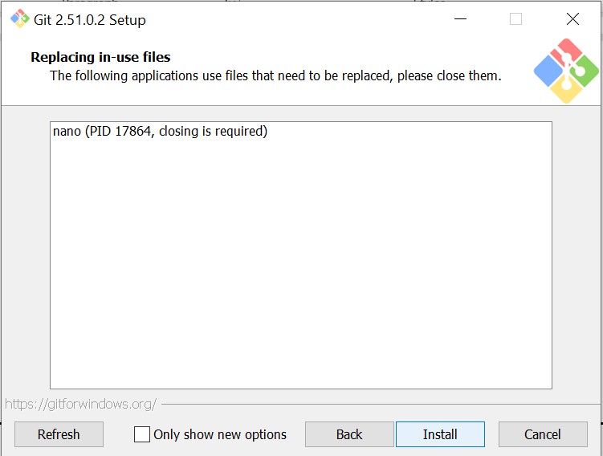

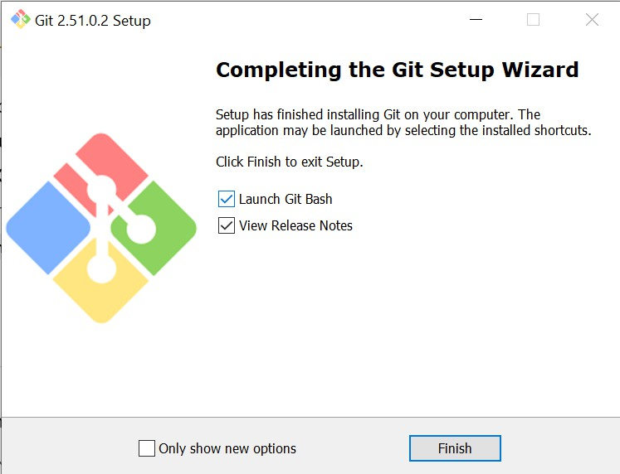

Task 1: Create Private GitHub Repository
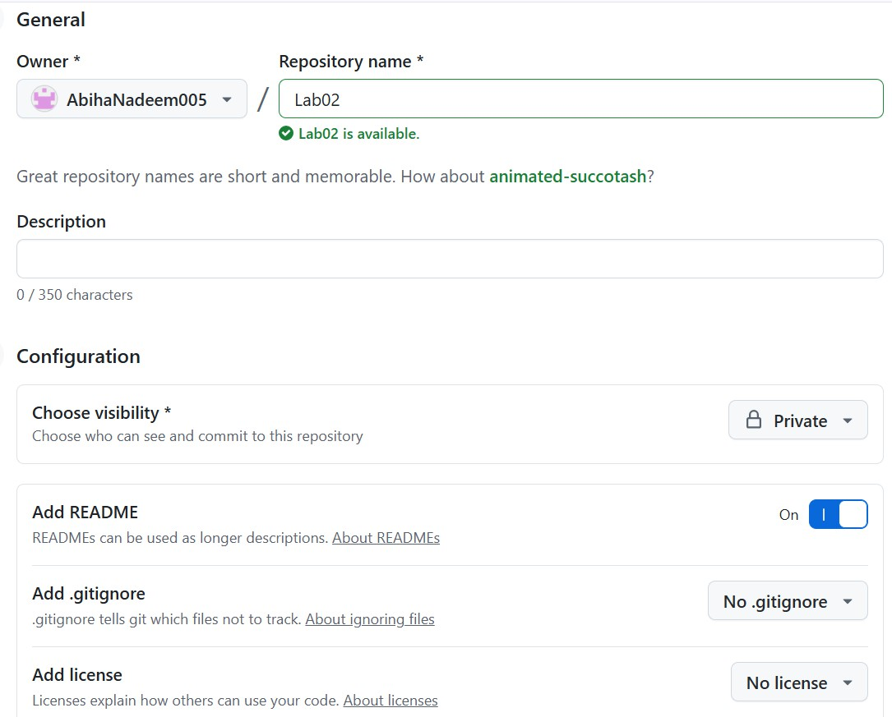

Task 2: Connect Repository via SSH
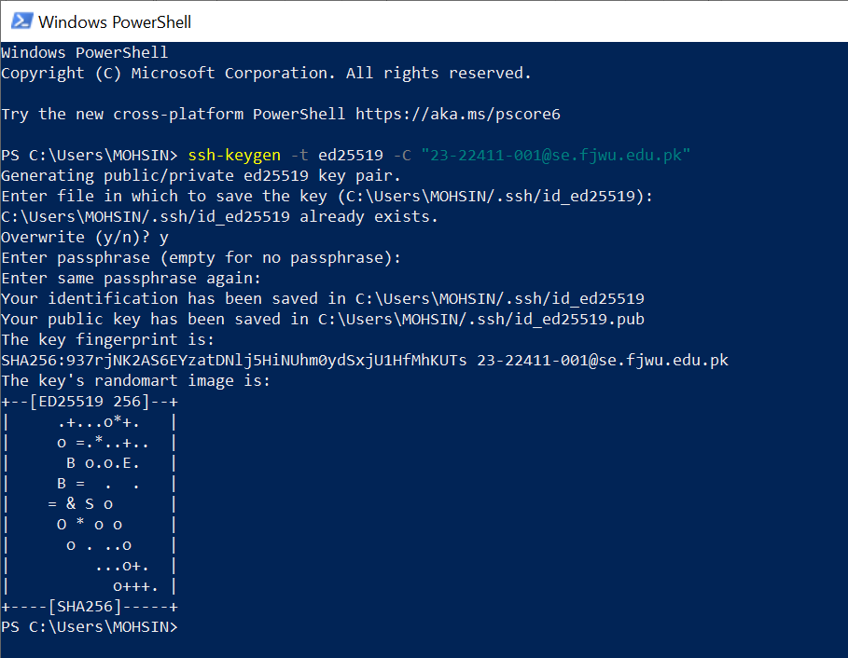

Add your SSH public key to GitHub (Settings > SSH and GPG keys).
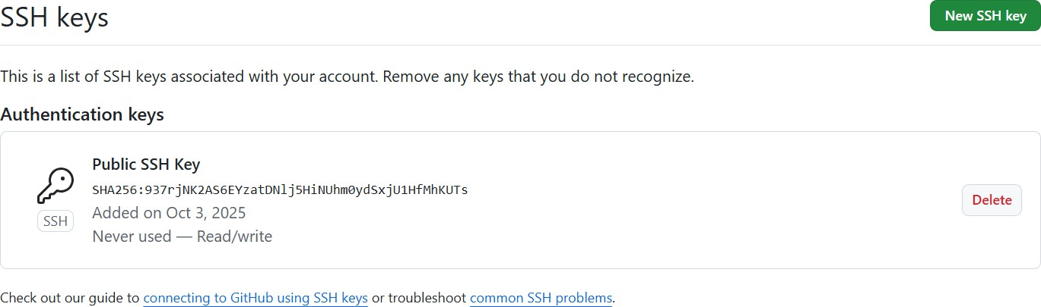

Clone your Lab2 repo using SSH.
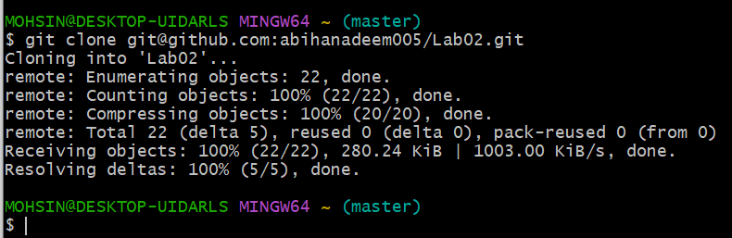

Task 3: Configure Git Username and Email

Set up your Git identity (this ensures all commits are linked to you):
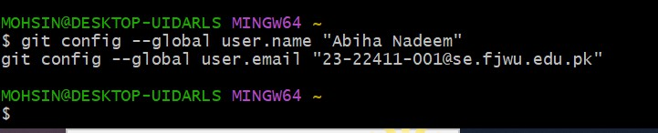

Verify your configuration:

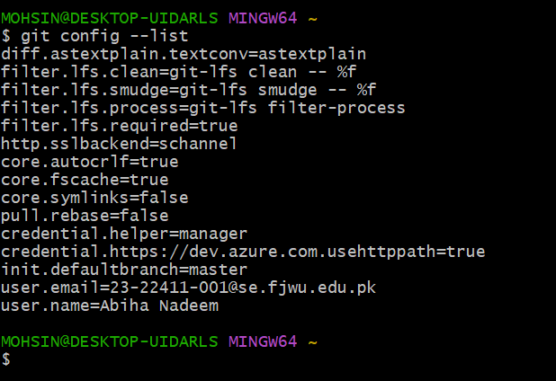

Task 4: Explore the .git Folder
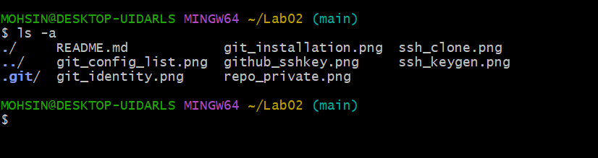

Task 5: Local Repository Management
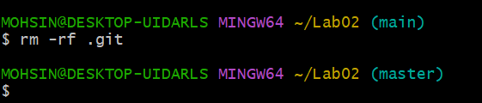

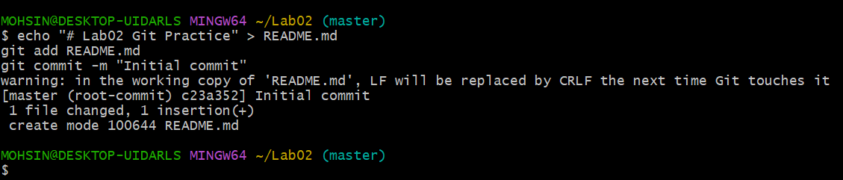
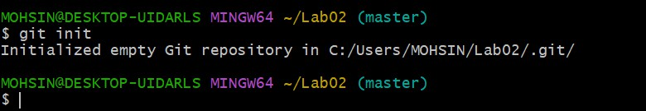
Re-initialize the local git repository:

Add a file named README.md and commit it:
Connect your local repo to GitHub and push:

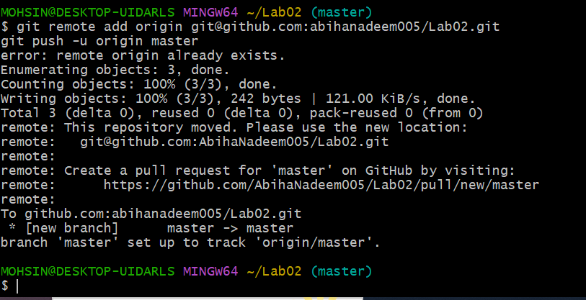
Task 6: File Status & Staging
- Create a new file notes.txt and write a note.
- Check status

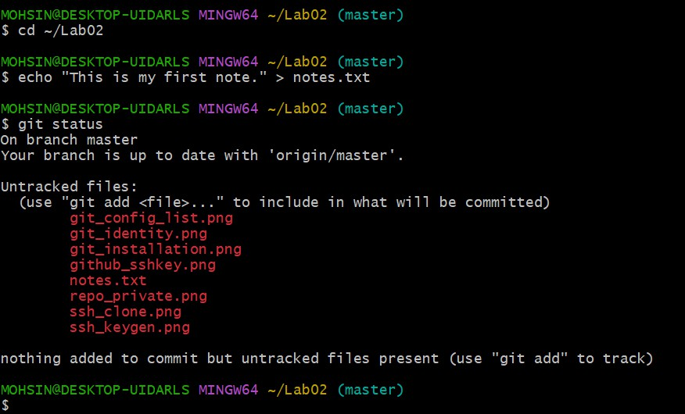
- Stage and commit
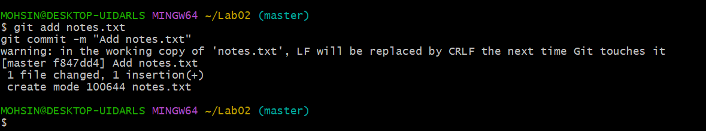
- Edit notes.txt and repeat status/commit steps.

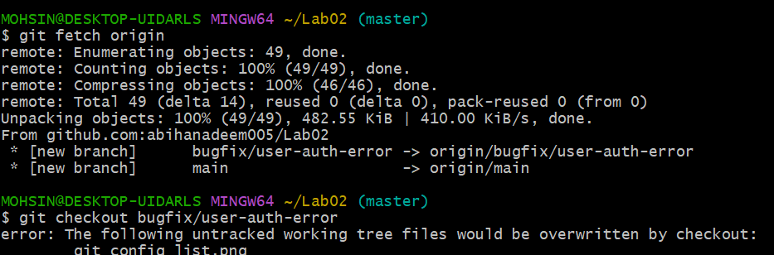
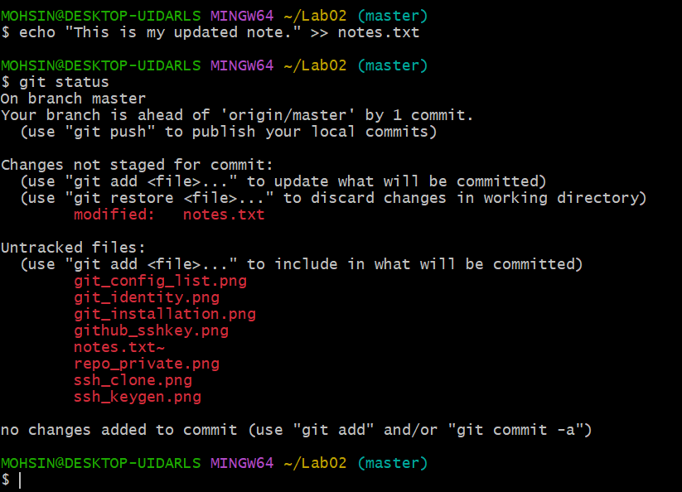
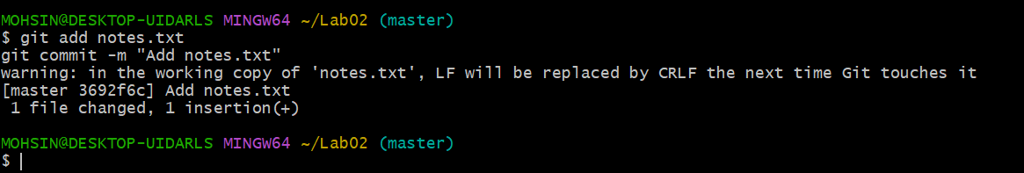

Task 7: Branch Creation Using GitHub GUI

  - On GitHub (web interface), create a branch named bugfix/user-auth-error.

  - Pull the branch to your local repository to sync.

T

Task 8: Branch Creation and Push Using Git Bash
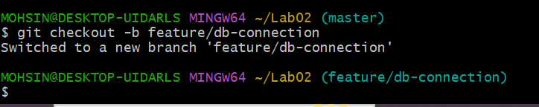
- Create a branch named feature/db-connection using Git Bash

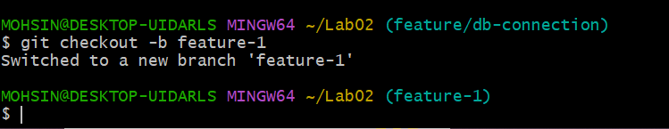
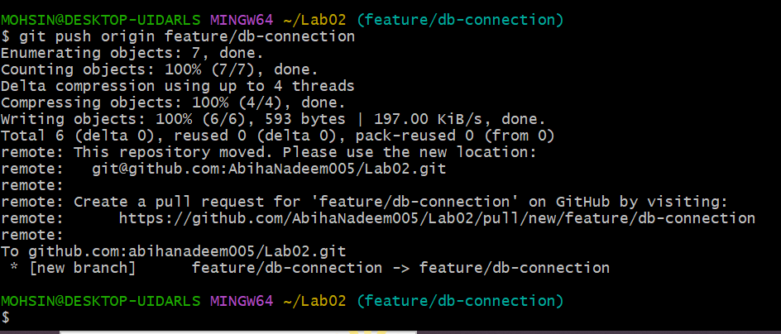
- Push the branch to the remote repository:

ask 9: Branching & Merging
1. Create and switch to a branch feature-1

- Modify main.py (add a function) and commit.
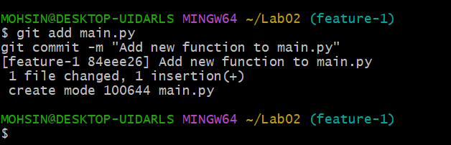

- Switch back to main and merge
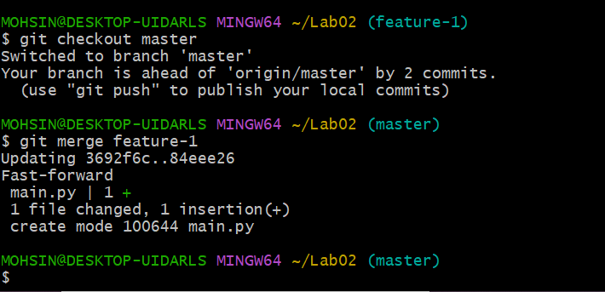

- Push all branches:

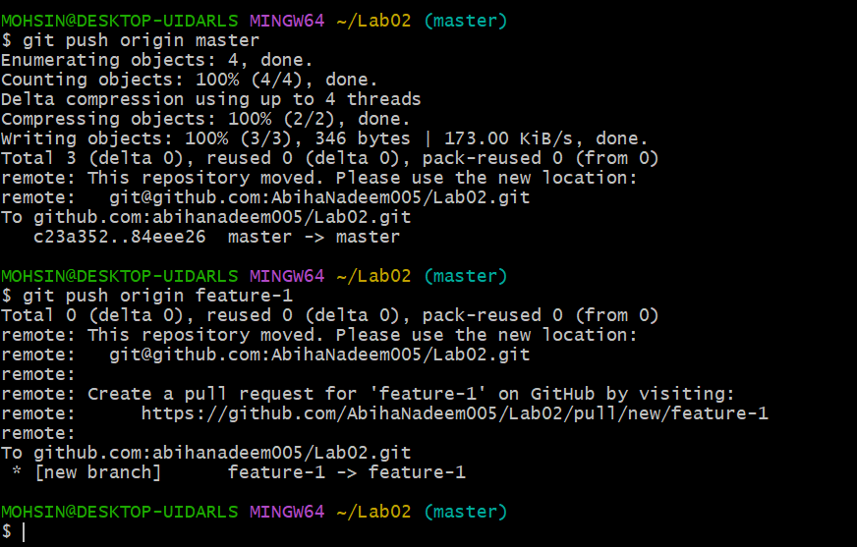

Task 10: Pull Request and Branch Review (GitHub GUI)

- On GitHub, create a Pull Request from the branch feature/db-connection to main.
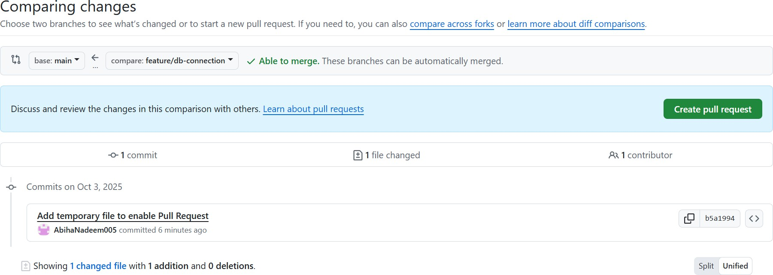

- Review the Pull Request and merge it using the GitHub GUI.

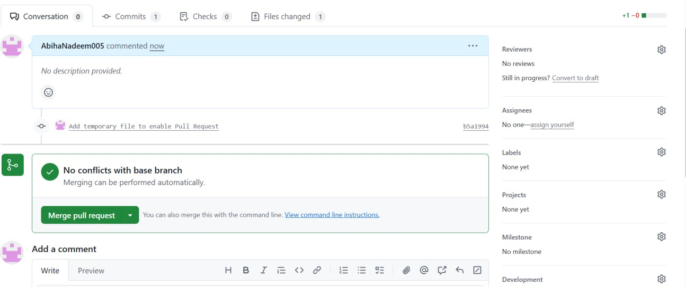
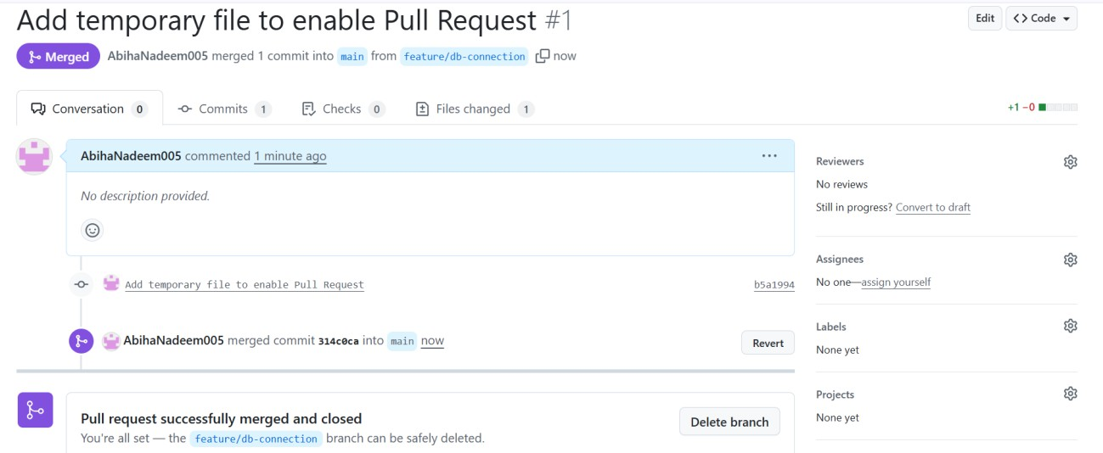

- After merging, delete the feature/db-connection branch using the GitHub GUI.
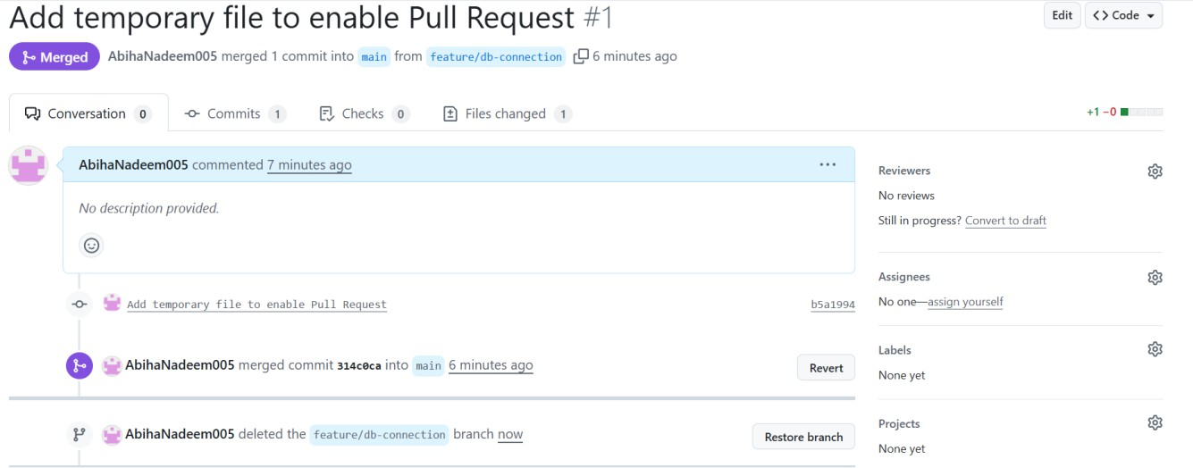

Task 11: Detailed Branch Strategy (Develop/Staging)
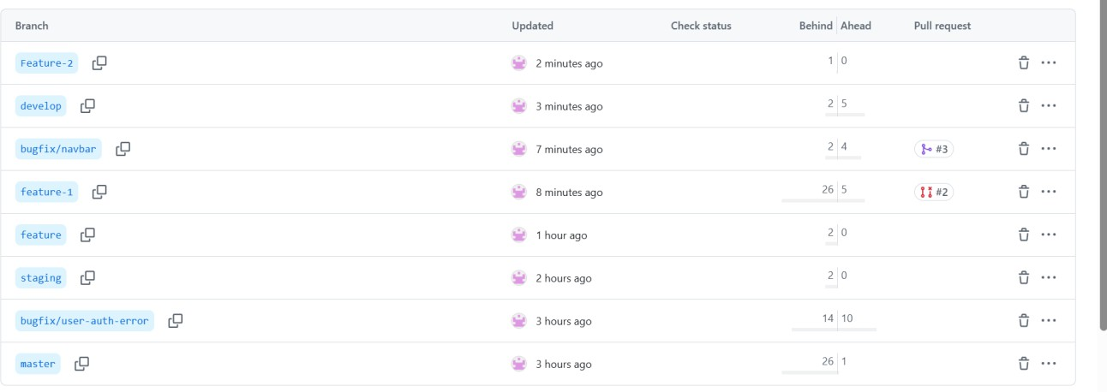
Branch list (branch_strategy.png)

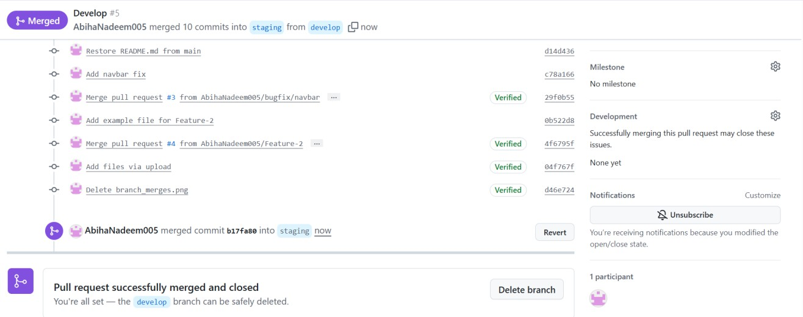
  - Merges into develop and staging (branch_merges.png)

- Final merge into main (final_merge.png)

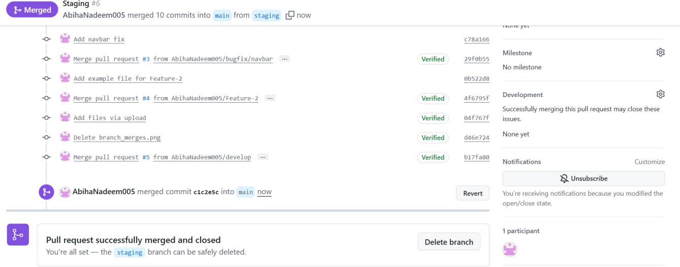
  - Final merge into main (final_merge.png)

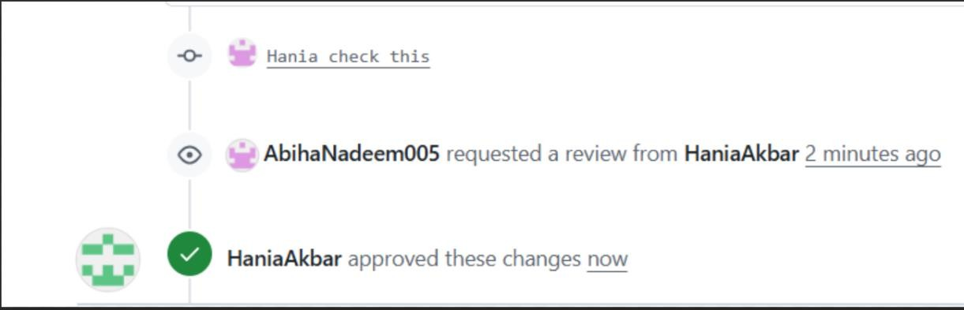
Task 12: Code Review Workflow

Create a Pull Request (PR) / Merge Request (MR):
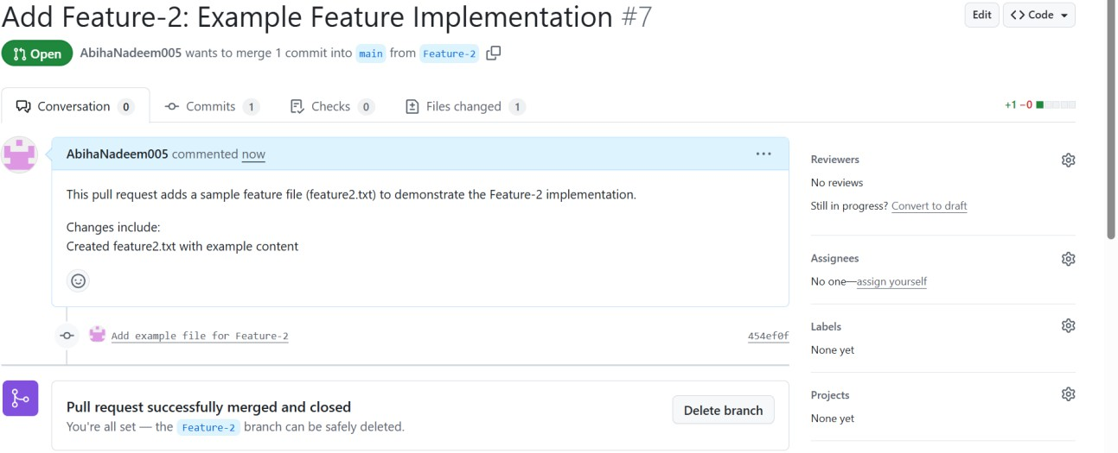

- Assign a reviewer (teammate or second account).
  - Screenshot as pr_assigned_reviewer.png.
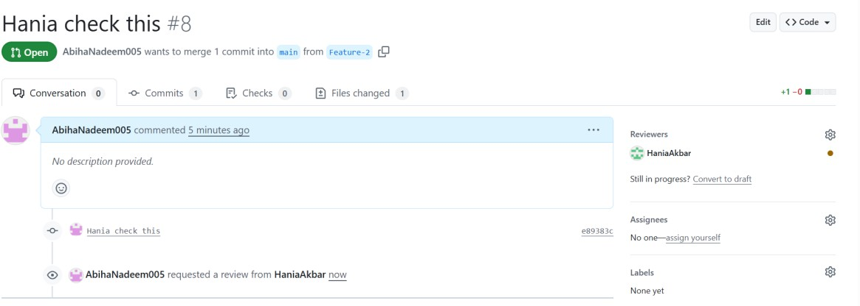

- Reviewer Actions (capture screenshots for each):
  - Approve the PR → pr_approved.png

- Merge the PR:
  - Screenshot confirmation → pr_merge_confirm.png.
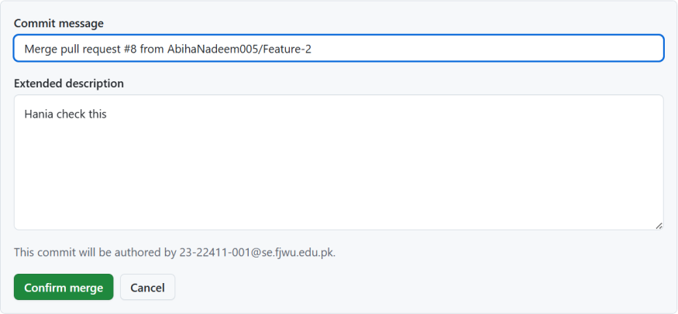

  - Screenshot result → pr_merged.png.
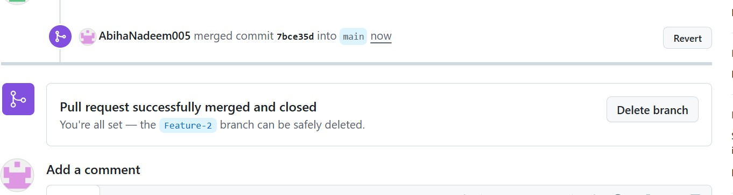

Branch Handling After Merge:
- If deleted, screenshot → pr_branch_deleted.png.
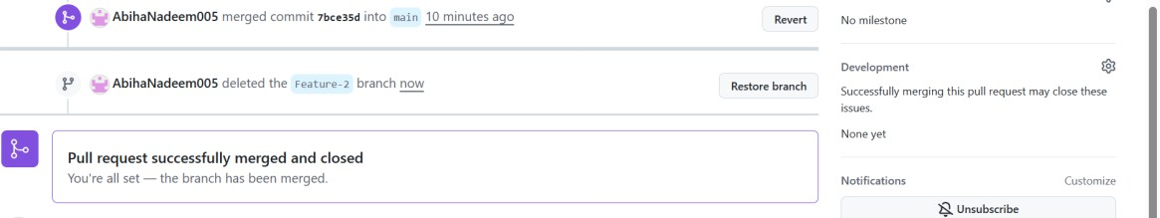

Task 13: Branch Cleanup Best Practices
- Delete Remote Branch After Merge:
  - Use GitHub UI → screenshot remote_branch_deleted.png.

- Screenshot as remote_branch_delete_cmd.png.




